<Autism Support Companion (MobileAPP)>

Design Document

Version 1.0



Group Id: <S240290598>
Supervisor Name :< Abdullah Qamar >

Revision History
Date (dd/mm/yyyy) | Version | Description | Author
10/07/2024 | 1.0 | Design Document includes Introduction of Design Document, Entity Relationship Diagram (ERD), Sequence Diagrams, Architecture Design Diagram, Class Diagram, Database Design, Interface Design and Test cases. | Bc200407858

Table of Contents

- Introduction (of the document)
- Class Diagram
- Database Design
- Interface Design
- Deployment Diagram
- Architecture Design Diagram
- Test Cases

Introduction of Design Document
Design Document plays important role in design and an analysis phase gives us a concrete understanding of all possible functionalities of our development. In the result, it provide description and overview of the product that being created and help while communication with the internal stakeholder and external stakeholders.

- Entity Relationship Diagram (ERD)
It is graphical representation of entities and relationships which helps in understanding that what data we will have to manipulate. In short an ERD used in computing in regard to organization of data within information system and essential to make conceptual database design.
- Sequence Diagrams
Diagram which will help in understanding the logic means how and in what order, objects works together when interaction take position. In conclusion we can say that it helps to understand that how a future system should behave with respect to time sequence.
- Class Diagram
It shows the classes of the system also the attributes, constraints, operation, methods and relationship among the objects used in object oriented modeling widely due to direct mapping.
- Database Design
It will show how the data will be classified and identification of Tables means how the Tables will be related to other Tables. ER play important role while database design and all data will be efficient while using database.
- Interface Design
HCI is concern subject which involved interfaces for end users due to which usability increase and user experience. It also involves the requirement of the end user needs.
- Architecture Design Diagram
It helps in understanding the layered or tiered architectures of project

- Test Cases
It involves the steps of the execution of the system that how input, exception, expected result of the case will occur. It satisfies the conditions that our requirements are fulfilled or not means system work correctly or not.

Design Document Overview
The Autism Support Companion App is a mobile application designed to provide a supportive digital tool for individuals on the autism spectrum, their caregivers, and therapists. The app aims to offer features and functionalities that assist in managing daily tasks, communication, emotional regulation, and social skills development. This design document will guide the development of the app, ensuring that it meets the requirements and needs of its users.
>
- Entity Relationship diagram
This ERD uses a handwritten font and a light gray background to give it a friendly and approachable feel. The entities are represented as rectangles with bold font, and the relationships between them are shown as lines with arrowheads.
Here's a brief explanation of each entity and its relationships:
- User: Represents a user of the app, with a unique UserId and other personal details.
- Profile: Represents a user's profile, with preferences, sensitivities, and communication needs.
- SensorySupport: Represents sensory support resources, such as calming exercises and sensory-friendly content.
- CommunicationTool: Represents communication tools, such as AAC methods and customizable communication boards.
- Task: Represents tasks and reminders for daily routines and time management.
- SocialSkill: Represents social skills training modules and activities.
- EmotionalRegulation: Represents emotional regulation techniques and exercises.
- Accessibility: Represents accessibility features, such as font size adjustment and text-to-speech capabilities.
Each entity has a unique primary key (PK) and may have foreign keys (FK) that reference other entities. The relationships between entities are shown as lines with arrowheads, indicating the direction of the relationship.

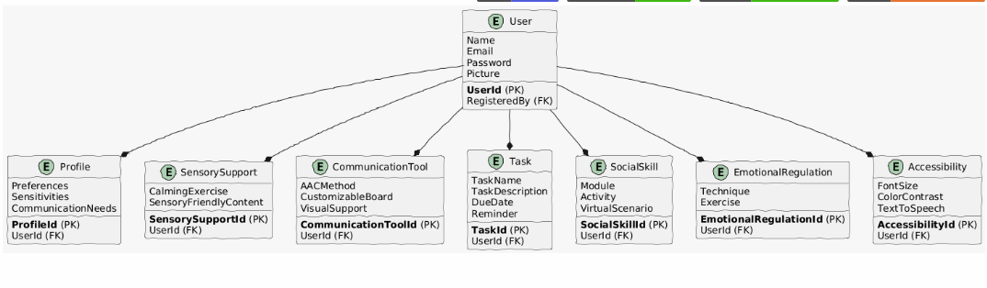

2.Class Diagram

<The Class Diagram shows the classes of the system, including attributes, constraints, operations, methods, and relationships among objects. It is widely used in object-oriented modeling due to its direct mapping.
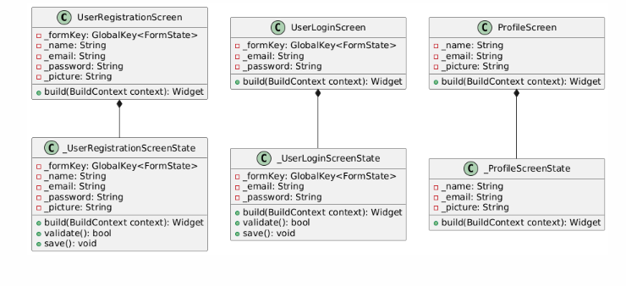>

3.Database Design

<Entities (Tables)
- Users
  - UserId (Primary Key, Varchar(10))
  - Name (Varchar(100))
  - Email (Varchar(100))
  - Password (Varchar(100))
  - Picture (Blob)
  - RegisteredBy (Varchar(10)) // Parent/Guardian ID
- Profiles
  - ProfileId (Primary Key, Varchar(10))
  - UserId (Foreign Key, Varchar(10))
  - Preferences (Text(1000))
  - Sensitivities (Text(1000))
  - CommunicationNeeds (Text(1000))
- SensorySupport
  - SensorySupportId (Primary Key, Varchar(10))
  - UserId (Foreign Key, Varchar(10))
  - CalmingExercise (Text(1000))
  - SensoryFriendlyContent (Text(1000))
- CommunicationTools
  - CommunicationToolId (Primary Key, Varchar(10))
  - UserId (Foreign Key, Varchar(10))
  - AACMethod (Varchar(100))
  - CustomizableBoard (Text(1000))
  - VisualSupport (Text(1000))
- TaskManagement
  - TaskId (Primary Key, Varchar(10))
  - UserId (Foreign Key, Varchar(10))
  - TaskName (Varchar(100))
  - TaskDescription (Text(1000))
  - DueDate (Date)
  - Reminder (Time)
- SocialSkillsTraining
  - SocialSkillId (Primary Key, Varchar(10))
  - UserId (Foreign Key, Varchar(10))
  - Module (Varchar(100))
  - Activity (Text(1000))
  - VirtualScenario (Text(1000))
- EmotionalRegulation
  - EmotionalRegulationId (Primary Key, Varchar(10))
  - UserId (Foreign Key, Varchar(10))
  - Technique (Varchar(100))
  - Exercise (Text(1000))
- Accessibility
  - AccessibilityId (Primary Key, Varchar(10))
  - UserId (Foreign Key, Varchar(10))
  - FontSize (Varchar(10))
  - ColorContrast (Varchar(10))
  - TextToSpeech (Boolean)
Relationships
- A user can have one profile (One-to-One).
- A user can have multiple sensory support resources (One-to-Many).
- A user can have multiple communication tools (One-to-Many).
- A user can have multiple tasks (One-to-Many).
- A user can have multiple social skills training modules (One-to-Many).
- A user can have multiple emotional regulation techniques (One-to-Many).
- A user can have one accessibility setting (One-to-One).
This database schema diagram captures the main entities and relationships described in your project. Note that this is a simplified representation, and you may need to add or modify entities and relationships based on your specific requirements.
>

4.Interface Design

<Human-Computer Interaction (HCI) is a key concern in interface design. This section focuses on creating user interfaces that are intuitive, accessible, and user-friendly, considering the needs and requirements of end-users.
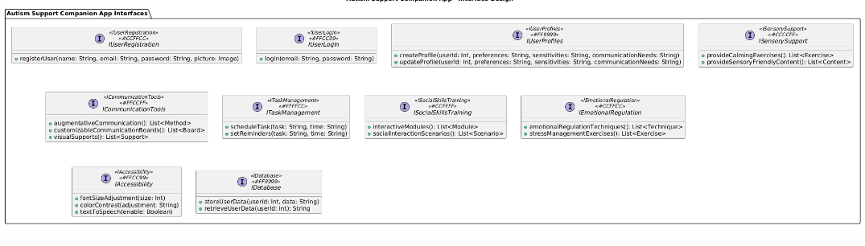>

5.Deployment Diagram

<The Autism Support Companion App, developed for Android using Flutter, focuses on user-friendly features like secure registration, customizable profiles with sensory support and communication tools, task management, social skills training, emotional regulation exercises, and accessibility options. It utilizes Firebase for reliable cloud storage, ensuring data security, while prioritizing intuitive UI/UX design to enhance the daily lives of individuals on the autism spectrum, caregivers, and therapists through a supportive digital platform.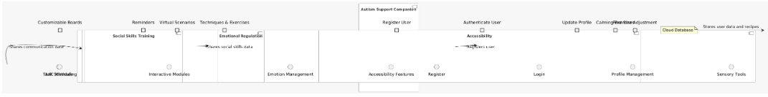 >
6.Use case Diagram
<The Autism Support Companion App Use Case Diagram illustrates the interactions between the system and its users, including individuals with autism, their caregivers, and therapists, comprising 9 use cases and 3 actors: User, Parent/Guardian, and Therapist. The use cases include Register, Log in, Update Profile, Access Sensory Support, Access Communication Tools, Manage Tasks, Practice Social Skills, Regulate Emotions, and Adjust Accessibility, which cater to the diverse needs of users, providing a comprehensive platform for managing daily tasks, communication, emotional regulation, and social skills development.

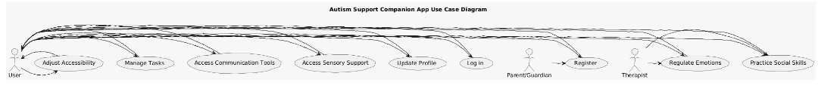>

7.Architecture Design Diagram
The Autism Support Companion App's architecture design diagram showcases a 5-layered structure, consisting of Presentation, Application, Business Logic, Data Access, and Infrastructure layers, which collectively manage user interactions, requests, core logic, data storage, and underlying infrastructure, ensuring a robust and efficient system.

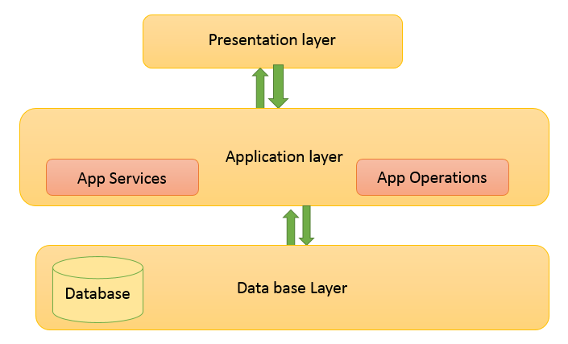

8.Test Cases

<Test Case: Approve and Activate User Registration
- Id: UC001
- Actors: Admin
- Description: The admin approves and activates user registrations for both individuals on the autism spectrum and their caregivers or therapists.
- Pre-Conditions: Admin is authenticated and has access to the admin panel.
- Task Sequence:
  - Admin logs in to the admin panel.
  - Navigates to the "User Registration" section.
  - Reviews registration requests.
  - Approves or rejects registrations.
  - Activates approved accounts.
- Exceptions: If there is an issue with the approval or activation, display an error message.
- Post Condition: Approved users can log in to the system.

Test Case: Manage Sensory Support Tools
- Id: UC002
- Actors: Admin
- Description: Admin oversees and maintains the sensory support tools, ensuring they meet user needs.
- Pre-Conditions: Admin is authenticated and has access to the admin panel.
- Task Sequence:
  - Admin logs in to the admin panel.
  - Navigates to the "Sensory Support Tools" section.
  - Adds, modifies, or removes tools based on user feedback and needs.
- Exceptions: If there is an issue saving changes, display an error message.
- Post Condition: Sensory support tools are updated to meet user needs.

Test Case: Generate Analytics and Reports
- Id: UC003
- Actors: Admin
- Description: Admin analyzes system performance, user engagement, and effectiveness of tools and exercises.
- Pre-Conditions: Admin is authenticated and has access to the admin panel.
- Task Sequence:
  - Admin logs in to the admin panel.
  - Navigates to the "Analytics" section.
  - Generates reports on system usage and effectiveness.
- Exceptions: N/A
- Post Condition: Admin gains insights to improve the Autism Support Companion App.

Test Case: Customize Communication Tools
- Id: UC004
- Actors: Caregiver/Therapist
- Description: Caregiver or therapist customizes communication tools to meet the specific needs of the individual with autism.
- Pre-Conditions: Caregiver or therapist is authenticated.
- Task Sequence:
  - Logs in to the app.
  - Navigates to the "Communication Tools" section.
  - Customizes communication boards and visual supports.
- Exceptions: If there is an issue saving changes, display an error message.
- Post Condition: Communication tools are customized and saved.

Test Case: Schedule and Manage Tasks
- Id: UC005
- Actors: User/Caregiver
- Description: User or caregiver schedules and manages daily tasks and reminders.
- Pre-Conditions: User or caregiver is authenticated.
- Task Sequence:
  - Logs in to the app.
  - Navigates to the "Task Management" section.
  - Schedules tasks and sets reminders.
- Exceptions: If there is an issue saving tasks, display an error message.
- Post Condition: Tasks are scheduled and reminders are set.
>

